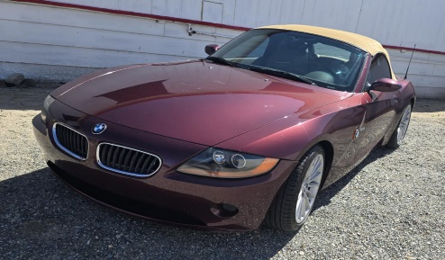
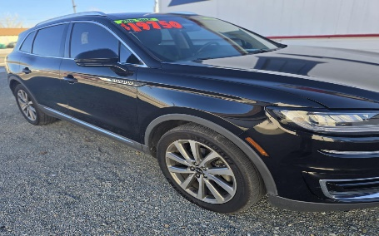
B and C Estate Sales, Inc
Cars Are Available now!!!!
2019 Lincoln Nautilus, 2003 BMW Z4 Roadster Convertible 2.5 I, 1963 Rolls Royce Silver Shadow right hand drive.
A Hobbyist Paradise Estate Sale in Hawthorne NV
June 5th, 6th, 7th, and 8th 10am-5pm
13 RC Air Planes with remotes, Tools, Craftsman tool box, Xmas items, Craft items, Antique Shaffer saxophone in case, Patio Furniture Maple Hutch, Coins, Jewelry, Corning ware, small appliances, Maple table w/2 leaves & 6 chairs, matching Chandelier, Yamaha keyboard, Blue tea set, Pope Gosser China set (Made in USA sterling),Ekco International China set, Fiesta teapot, Old Cast Iron, Cobalt blue glass, bird bath, garden tin man figure, router table, Grandfather Clock, salt lamp, fisherman lamp, Kitchen cooking pans, Spoon Collection, fisherman figures, digital camera, jewelry chest, Dresser w/2 matching nightstands, queen size bed (adjustable), sewing machines, Cedar chest (handmade), Trieger wood pellet Grill, Lawnmower, Tea cups and pots, clothes, figurines, Lamps, LP Elvis & Disney, 1950’s coffee and end tables, Portable Ice Maker, Mixer, and much more
******Watch for our orange signs*******
Address will be posted on our website (listed At bottom of page) and Estatesales.org and Estatesales.net the night before sale opens

Directions From: Las Vegas : Head Northwest on steward Ave towards Las Vegas Blvd. N, turn right onto N 4th ST, keep left to stay on N 4th ST, use any lane to take US95 N ramp, merge onto I-11/US-95 turn right onto US-95 N/main St signs for Tonopah, slight left onto us-95 N/crook Ave, turn left onto E St, left on 1st ST, right to Ash St
From Reno: I 80 E Towards Sparks, merge onto I-80 E, take exit 32 for Route 439/USA PKWY, Merge onto NV-439/USA PKWY, slight right towards CA Emigrant Trail sings for US-50 W/ carson city, merge to CA Emigrant trail, turn left onto Ramsey cutoff/Ramsey weeks cutoff, turn right to say on US-95 ALT S, turn left to stay on us-95 S (1mile), turn left to stay on US-95 S (23.3mi),turn right onto us-95 s signs for Hawthorne/Tonopah/Las Vegas, continue straight onto E ST, left on 1st ST, right to Ash St

Store Address: 785 E Street Hawthorne NV 89415 Phone # 916-482-7888
Email: Bcestatesales@gmail.com Website: https://norcalestatesales.com ( Hawthorne Tab)
Facebook: B and C Estate Sales, Inc Hawthorne NV
******* Hawthorne’s only UHaul Rental Dealer and Car Dealer ********

